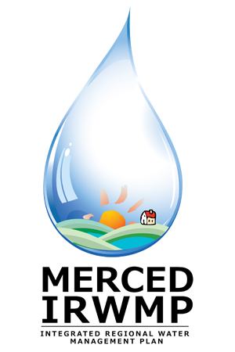

Merced Integrated Regional Water Management (IRWM) Plan
Regional Advisory Committee Meeting #7
Tuesday November 27, 2012
2:00 pm – 5:00 pm
The Sam Pipes Room
1st floor of the Civic Center (City Hall)
678 W. 18th Street
Merced, CA 95340

- Introductions and Overview 15 Min
- DWR Update 5 Min
- RAC Activities and Materials 10 Min
- Governance Approach 30 Min
- Summary of IRWM Projects Received 90 Min
  - Summary of Projects and Prioritization
  - Potential Changes to DAC Scoring (options presented by RAC Workgroup)
- Next Steps 5 Min
- Public Comment 5 Min

